Predict First Notes
1. Association
Prediction: I expected a PhysicalProduct object to access its Supplier object through the get_supplier() method.
What happened: The laptop successfully retrieved and displayed its supplier information.
Changes made: No changes were required.
2. Aggregation
Prediction: I expected a Product object to continue existing even after it was removed from an Inventory object.
What happened: The laptop was successfully removed from Inventory A and added to Inventory B.
Changes made: No changes were required.
3. Composition
Prediction: I expected each Order object to create and manage its own OrderLine objects.
What happened: Both orders successfully created their own OrderLine objects. The OrderLine objects were different even when they referenced the same Product.
Changes made: No changes were required.
4. Inheritance
Prediction: I expected PhysicalProduct and DigitalProduct to inherit common attributes and methods from the Product parent class.
What happened: Both subclasses successfully used the inherited Product methods.
Changes made: No changes were required.
5. Polymorphism and LSP
Prediction: I expected PhysicalProduct and DigitalProduct objects to work through references of the Product parent class.
What happened: Both product types successfully used common methods such as display_information(), get_stock() and update_stock().
Changes made: No changes were required.

UML Diagrams
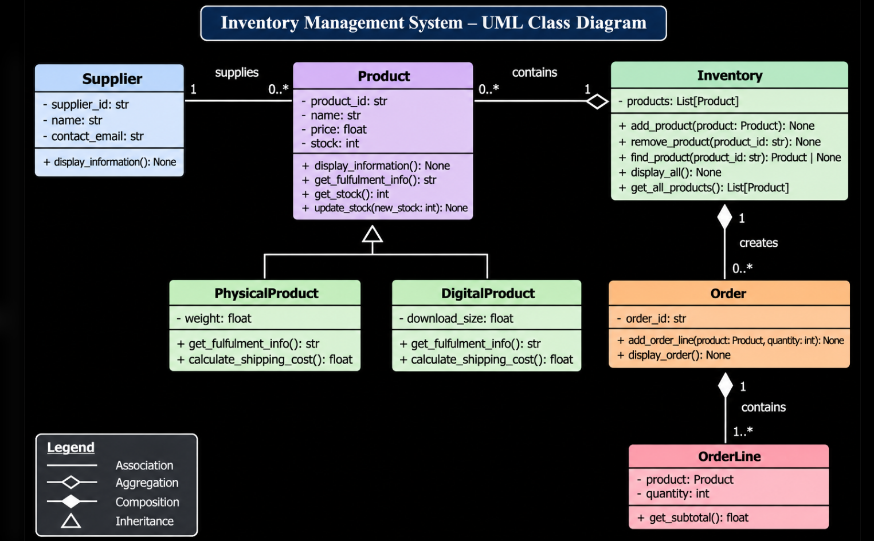

Type hints
Variable type hints -> self.products: list[Product] = []
parameter type hints -> add_product
return type hints -> find_product
list return type -> get_all_products
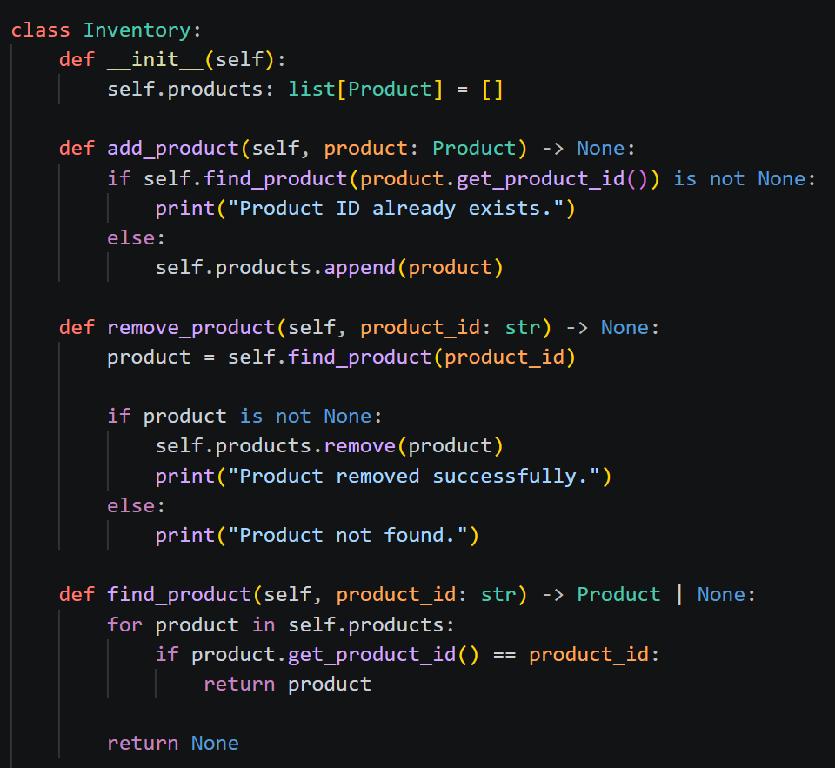
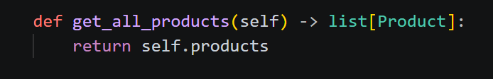

OOP Test screenshots


